1.Installing and configuring a databases management system.
Step 1- Download mysql installer.
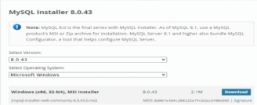

Step 2: Install and Configure MySQL
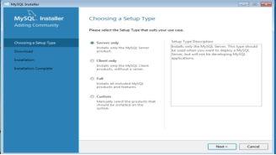
Step 3:-In the next window, just click “Execute.
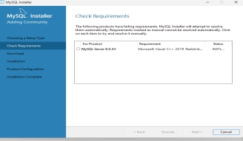
Step 4:-click “Next.”
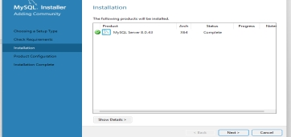
Step 5:-click “Next” to start the configuration.
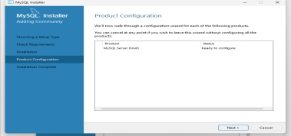
Step 6:- Then click Next.
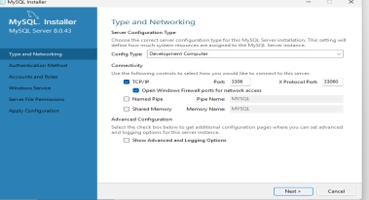
Step 7:- Then click next and set password ‘root’.
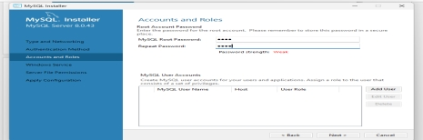
Step 8:-2 times next, then Execute and Finish.
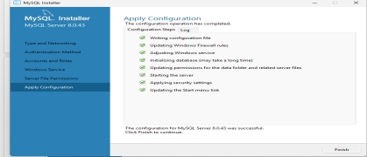
Step 9:- Download mysql workbench 8.0.43.
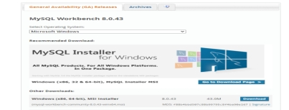
Step 10:- 3 time next and install.
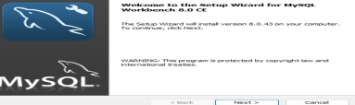
Step 11:- Then click Finish.
